**Corrosion behavior of liquid phase sintered SiC with Al2O3/Y2O3 additives in molten FLiNaK at 650°C**

Wande Cairang1,2, Weiyue Zhou2, *, Keshav Vasudeva1,2, Kevin Woller2, Sara E. Ferry2, Michael P. Short1,2,*

*1* *Department of Nuclear Science and Engineering,* *Massachusetts Institute of Technology, Cambridge, MA 02139, USA*

*2* *Plasma Science and Fusion Center (PSFC), Massachusetts Institute of Technology, Cambridge, MA 02139, USA*

**Abstract:**

The corrosion behavior of liquid-phase sintered (LPS) SiC with Al₂O₃/Y₂O₃ additives, exposed to molten FLiNaK at 650°C, has been investigated using experimental techniques and DFT simulations. Experimental findings show that bulk SiC foil disintegrates rapidly when in contact with molten FLiNaK. This is attributed to the reaction between KF and Al₂O₃ at the grain boundaries, leading to the formation of KAlO₂ and KAlF₄. This reaction weakens the binding between SiC grains, allowing molten salt to infiltrate throughout the sample, ultimately causing its dismantling. Additionally, the reaction between SiC and KF produces Si-F bonds, with K₂SiF₆ being the predominant product. However, the reaction between KF and SiC is less favorable compared to that with Al₂O₃. DFT calculations corroborate these findings, showing that the adsorption energy of KF on O-terminated Al₂O₃ is approximately one order of magnitude higher than that on Si-terminated SiC, indicating a stronger interaction with Al₂O₃.

**1. Introduction**

SiC-based materials are considered potential components for nuclear applications due to their superior strength, thermal properties, and low activation under neutron radiation [1, 2]. However, these materials are also supposed to possess good chemical compatibility when exposed to various environmental fluids [3, 4]. For example, in molten salt reactors (MSRs), SiC-based materials have been proposed as key components that come into contact with commonly used fluoride salts, such as FLiBe (66 mol% LiF-34 mol% BeF₂) or FLiNaK (46.5 mol% LiF-11.5 mol% NaF-42 mol% KF) as promising fuel solvents or coolants [5, 6]. Unlike metals and alloys, SiC-based materials are normally designed to serve in oxygen-deficient environments where they do not form a passive oxide layer when exposed to molten salts. However, understanding the corrosion mechanisms of SiC-based materials in molten salts still needs further investigations due to the complicated compatibility conditions, including various impurities in the salts and the complex chemistry and microstructure in the SiC matrix.

To date, both experimental and simulation studies have been conducted to investigate how SiC reacts with different molten salts [7-9]. It has been shown that pure SiC can undergo corrosion in molten salts through the formation of Si-F bonds by reacting with impurities such as metal fluorides. Gu et al. observed experimentally that SiC forms a depletion layer where Si leaches out into molten FLiNaK at 800°C, leading to a C-enriched layer behind [7]. Xi et al. used *ab* initio molecular dynamics (MD) to study the thermodynamical potentials of Si and C in fluoride salt and the rearrangement of dissolved Si, C species. They revealed that Si dissolves more easily in salts than C due to its more grounded potential, and the dissolved Si ion combines with F ions in the salt, forming SiF62- [8].

Moreover, metal impurities in liquid salts also play a crucial role in the degradation of SiC. Xue et al. experimentally demonstrated that Cr3+ in FLiNaK significantly enhances the corrosion of Si by a factor of ~5 compared to pure salts by forming different chromium carbides (Cr7C3 and Cr3C2). [9]. Other than Cr, metallic impurities commonly reported include Fe and Ni from structural alloys. Yang et al. investigated the effect of oxygen impurities in SiC on the corrosion of SiC in molten FLiNaK at 700°C, revealing that oxygen accelerates SiC corrosion with increasing oxygen concentration in the salt. Oxygen forms silicon oxide, which is dissolved by cleaving the Si-O-Si bonds with F, forming Si-O-F [10]. In a tritium environment, metal impurities in SiC can interact with tritium fluoride (TF), leading to the formation of metal fluoride oxides. These reactions can further deteriorate the integrity of SiC [6]. Beyond chemistry, the microstructure of SiC also affects its corrosion behavior. It has been shown that the corrosion rate of SiC is nearly seven times higher in samples with 32% high-angle grain boundary (HAGB) content compared to those with 19% HAGB content. However, grain size appears to have less influence on the corrosion rate of SiC [11].

Another source of impurities affecting the interaction between SiC and molten salt is the additives used during the manufacturing process. Metallic oxides, such as Al2O3 and Y2O3, or metallic elements like B, are commonly introduced into SiC as sintering agents. These additives enhance SiC's ductility and fracture toughness, playing a crucial role in tuning its mechanical properties [12, 13]. However, the effect of sintering additives on the chemical compatibility between SiC and molten salts remains obscure. It has been shown that B additives at grain boundaries in pressureless-sintered SiC can react with HCl and water, causing intergranular corrosion when exposed to molten NaCl–KCl–MgCl2 salt at 700°C [14]. Hu et al. also observed significant corrosion of pressureless sintered SiC with B additives in FLiNaK at 700°C, attributing the corrosion to metallic impurities in the molten salt that attract Si from SiC, while the contribution of B was not mentioned [15].

In this study, the corrosion behavior of liquid-phase-sintered (LPS) SiC with metallic oxide additives (Al2O3-Y2O3) was investigated by exposing it to molten FLiNaK at 650°C, as referenced in our previous study [16]. Scanning Electron Microscopy (SEM) combined with Energy Dispersive X-ray Spectroscopy (EDS) and Electron Probe Micro-Analyzer (EPMA) were used to probe the microstructures and elemental distribution. X-ray Photoelectron Spectroscopy (XPS) was used to identify possible reaction products by analyzing the binding energy. Density Functional Theory (DFT) simulations within the Vienna Ab initio Simulation Package (VASP) framework were conducted to further support the experimental results. Our study reveals that LPS SiC undergoes significant corrosion via penetration of molten salt into the sample, resulting in the disintegration of the sample foil. KF could react with Al2O3 to form KAlO2 and KAlF4, which permeates the sample foil and exacerbates the breakdown of SiC. Density Functional Theory (DFT) calculations show that the adsorption energy of KF on Al2O3 is nearly six times higher than on SiC. This indicates a greater propensity for the formation of KAlO2 over Si-F bonds in the initial stages of corrosion.

**2. Experiments and Simulations**

**2.1 Static corrosion**

The LPS SiC samples, 60 µm thick and 20 mm in diameter, were supplied by Aspericon Company. For conducting static corrosion in molten salt, nominally 99.9% pure solid FLiNaK, from Copenhagen Atomics was first placed in the Ni corrosion cell, as shown in Fig. 1(a), where the solid salt is marked by a white arrow. The LPS SiC sample foil was then positioned on top of the corrosion cell for sealing, as shown in Fig. 1(b), with one side exposed to molten salt at high temperature. The sample was secured to the corrosion cell by covering it with a flange and tightening it with six bolts, as shown in Fig. 1(c). The above steps were accomplished in an Ar environment within a glovebox to minimize the affection from moisture and oxygen. Following this procedure, the corrosion cell was transferred from glovebox and placed horizontally in a vacuum tube, as shown in Fig. 1(d). Additionally, non-volatile oxygen getters obtained from SAES Getters USA, Inc., with a nominal composition of 70 wt% Zr, 24.6 wt% VC, and 5.4 wt% Fe, were positioned in the vacuum tube to further achieve a low oxygen environment while pumping it down at high temperatures. The vacuum tube was then connected to a turbomolecular pump and installed in a muffle furnace. Heating commenced once the pressure in the vacuum tube reached 10-6 torr, and the pressure was maintained at 10-7 torr during the molten salt corrosion and the subsequent cooldown. The heating profile is illustrated in Fig. 1(e). The temperature was initially held at 200°C and 400°C for 0.5 hours each to bake up the system. After baking, the temperature was increased to 600°C, and subsequently, the ramp rate was decreased as the temperature reached 650°C. The temperature was maintained at 650°C for 4 hours, after which the heat supply was stopped, allowing the test assembly inside the furnace to cool down to room temperature.

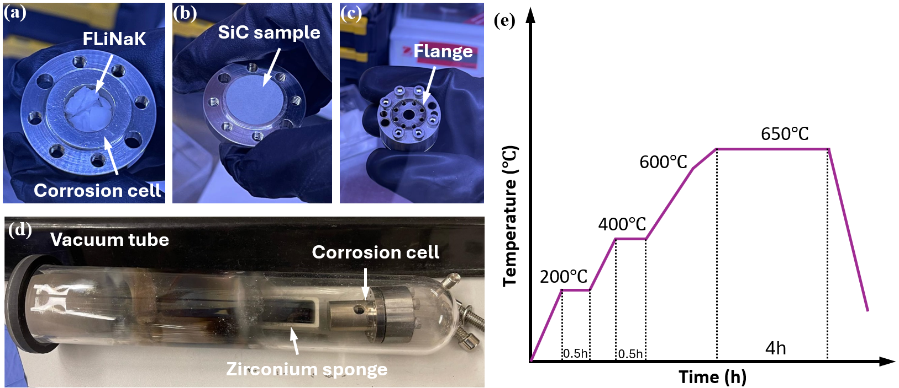

**Fig. 1.** Procedures of static corrosion of LPS SiC exposed to molten salt at 650°C. (a) FLiNaK is placed in a Ni-made corrosion cell. The corrosion cell is sealed with (b) a SiC sample and a flange tightened by 6 bolts (c). (d) A vacuum tube and Zircroalloy sponge are installed inside the corrosion cell. (e) Illustration of the temperature profile from the start of heating to shutdown.

After the static corrosion test, the sample was prepared for cross-sectional analysis using a JEOL cross-section polisher with a voltage of 6 kV and a current of 140 µA. The polished cross section was approximately 0.5 mm in width, providing a sufficiently large area for morphology and chemical analysis. Imaging and elemental analysis were performed using a Gemini 450 Zeiss SEM with EDX spectroscopy, operating at a current of 1.5 nA and a voltage of 15 kV. For EPMA, the voltage was 15 kV and the current was 10 nA. XPS was used to study potential corrosion products based on their binding energies. The beam spot size for XPS was 400 x 400 µm. A 1-minute Ar etch with a larger beam spot size was employed to remove most surface contamination before the test. The XPS data fitting was accomplished by Avantage software [17].

**2.2 DFT calculation methods**

First-principles calculations were performed using the Vienna Ab-initio Simulation Package (VASP) [18-20].

To compare the adsorption strength of KF molecules on SiC and Al₂O₃ substrates, surface models of SiC and Al₂O₃ were prepared using their common crystal structures. The bulk cell of SiC, consisting of 96 atoms, and the bulk cell of Al₂O₃, consisting of 72 atoms, were cleaved along the <001> direction to create the surface models, consistent with previous SiC studies [8].

The Perdew-Wang Generalized Gradient Approximation (GGA) and the Projector-Augmented Wave (PAW) method were employed for the construction of potentials [21, 22] . A cutoff energy of 530 eV was used for all calculations, with a convergence threshold for total energy set at 10-6 eV/atom. The threshold for interatomic force was set at 0.01 eV/Å. Atomic relaxations were considered during structural optimizations. For calculations of adsorption energy and electron localization function (ELF), the Monkhorst-Pack scheme was utilized for *k*-point sampling with a 4 × 3 × 1 *k*-mesh [22, 23].

The adsorption energy is calculated by:

$E_{ad}= E_{tot}- E_{sub}- E_{a}$ (1)

Where Ead is adsorption energy, Etot is the total energy, Esub is energy of system without adsorptive molecure, and Ea is the energy of the adsorptive molecule. HOMO-LUMO energy ΔE is calculated by subtracting HOMO energy from LUMO energy, which can be written as [24]:

$ΔE= E_{LUMO}- E_{HOMO}$ (2)

**3. Results**

**3.1 As-sintered microstructure and chemistry**

Fig. 2 illustrates the initial microstructure and chemical composition of the samples. The brighter particles in the secondary electron mode SEM image in Fig. 2(a) correspond to metal oxide additives. This observation is corroborated by the SEM-EDX mapping in Fig. 2(b), which reveals the presence of Al, Y, and O elements dispersed throughout the sample, in addition to Si and C. These oxides are distributed at the grain boundaries of SiC, as shown in the zoom-in image in the upper right corner of Fig. 2(c), which is an intergranular fracture facet. They function as bridges between the SiC grains, consistent with previous observations [25, 26]. The XRD results displayed in Fig. 2(d) confirm the polycrystalline structures of both SiC and the metallic oxide additives. It is also important to note that the sample exhibits a porous structure, with many cavities visible throughout the microstructure.

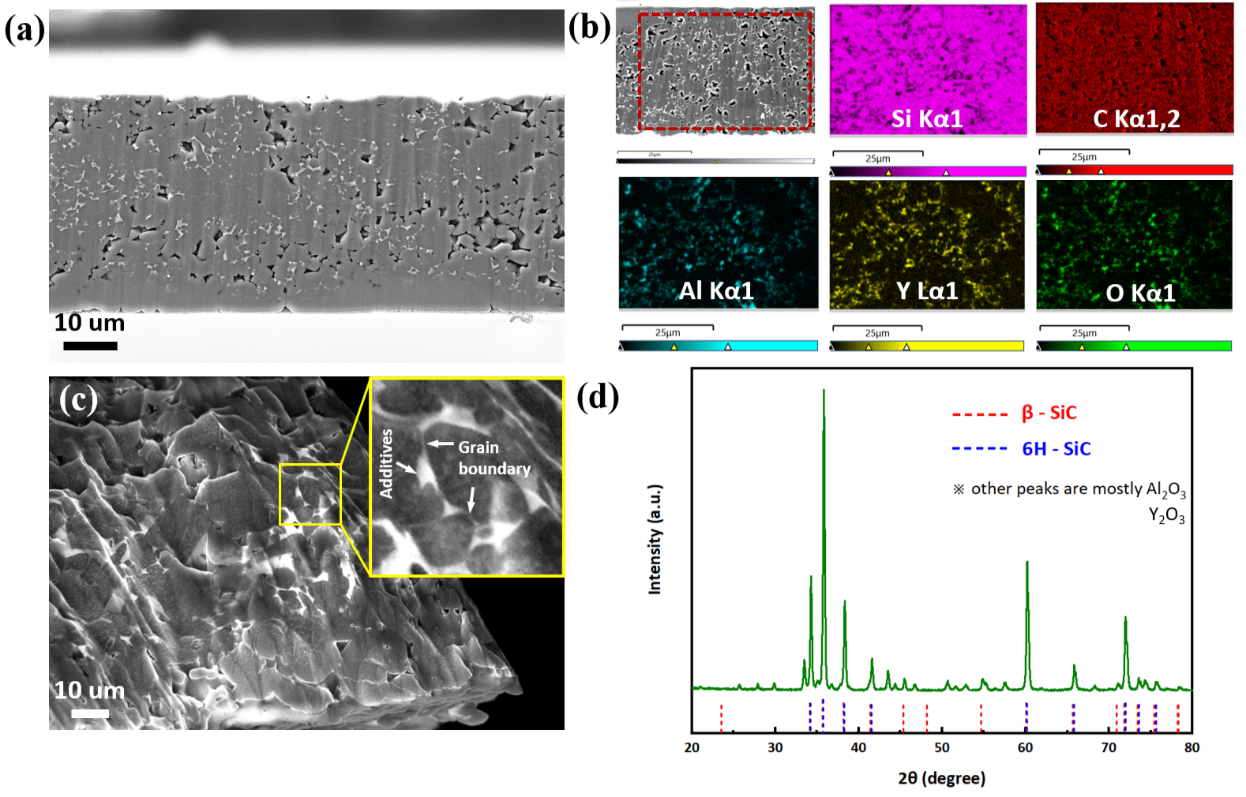**Fig. 2.** Microstructure and chemistry of LPS SiC. (a) SEM-SE image of microstructural morphology of LPS SiC cross section and its corresponding (b) EDX mapping. (c) fractural facet showing the metallic additives at grain boundary. (d) XRD pattern showing the crystal structure of LPS SiC matrix and metallic oxide additives.

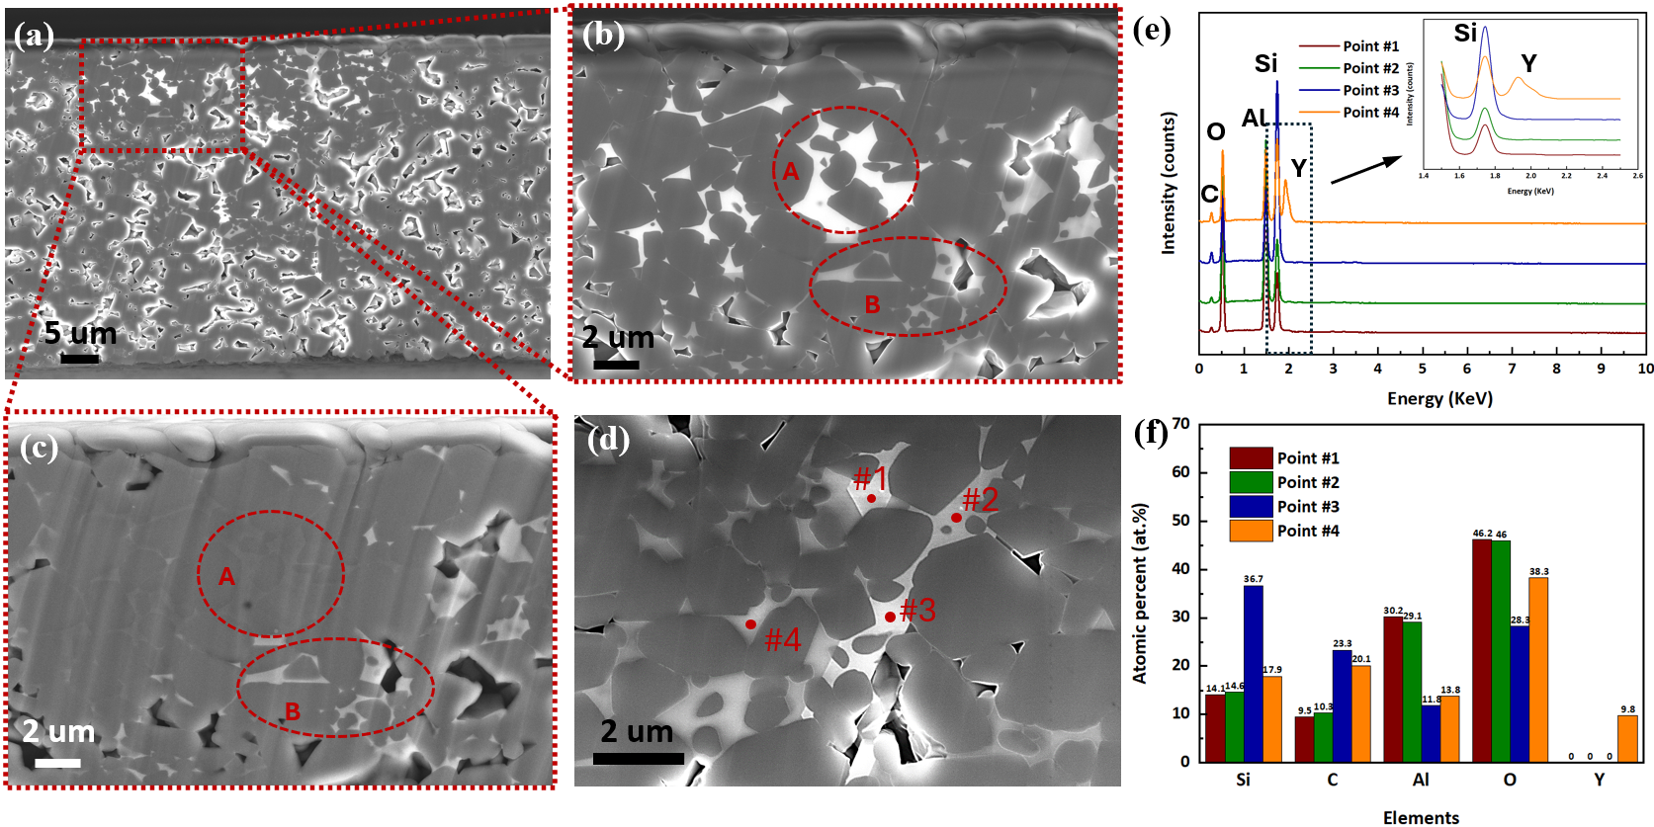

**Fig. 3.** Determination of chemical composition of oxide additives in LPS SiC by SEM and corresponding EDS point analysis. (a) SEM-InLens image showing a larger area of the cross-section of the sample. (b) and (c) are zoomed-in SEM-InLens and SE images from the rectangular region in (a), respectively. (d) SEM-InLens image showing a localized region where the EDS point analysis was conducted. (e) EDS spectrum at four locations in (d), and (f) corresponding atomic percentage for Si, C, Al, O, and Y.

Fig. 3 displays the chemical quantification of metallic oxide additives. In Fig. 3(b), an SEM-InLens mode image taken from the rectangular region marked by a red dashed line in Fig. 3(a), it can be observed that the contrast of the oxides differs in various areas - zone A, marked by a red circle in Fig. 3(b), appears much brighter than zone B, marked by the red ellipse. Interestingly, the SEM-SE mode image in Fig. 3(c), from the same region as Fig. 3(a), shows no contrast on the oxides in zone A, while the oxides in zone B remain visible. This suggests that the chemical composition is different in zone A and zone B due to the varying atomic mass contrast to back scattering electrons. An EDS point analysis was then performed on four regions showing different contrast, indicated by #1 to #4 in Fig. 3(d). The corresponding energy spectrum in Fig. 3(e) shows Al peaks across all four points, while no obvious Y peak appears in the first three points, but a strong peak is present at point #4. The atomic percentages for different elements are shown in Fig. 3(f). At point #1, the Al : O ratio is 30.2:46.2, which is nearly 2:3, indicating the presence of Al2O3. Similar results are found at point #2, where the Al : O ratio is 29.1:46, also approximating 2:3, suggesting Al2O3. At point #3, the Al : O ratio is 11.8:28.3, which is smaller than 2:3, indicating that excess O could be attributed by Y oxides. At point #4, the Al : O : Y ratio is 13.8:38.3:9.8. The sum of Al and Y percentages (13.8 × 3 + 9.8 × 3 = 70.8) is nearly equal to the O percentage (38.3 × 2 = 76.6), suggesting a mixture of Al2O3 and Y2O3.This difference in oxide chemistry can be further verified by the SEM-EDX line scan, as displayed in Fig. 4. In the less bright area, confined by the two parallel red dashed lines in Fig. 4(b), both Al and Y intensities increase while SiC decreases. In the brighter area, confined by the blue dashed lines, a strong Al intensity is observed with nearly zero Y intensity. This is consistent with the point analysis.

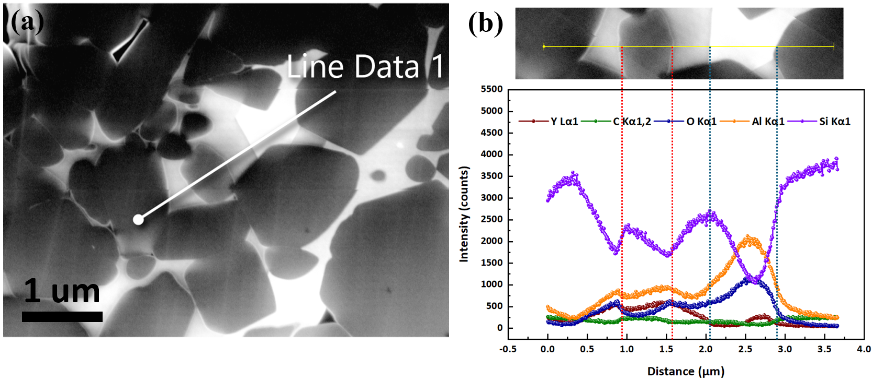

**Fig. 4.** (a) SEM-InLens image showing the area where the EDS line scan was conducted across the oxide additives. (b) EDS scanline results from the area shown in (a).

Table 1 provides the average weight percentage of elements in the LPS SiC used in this study. The EDS mapping data was collected from three different areas, each with dimensions of approximately 50 x 50 µm, to ensure the regions were large enough to avoid size-related effects. As seen in Table 1, Si and C have average concentrations of 57.97 wt.% and 28.93 wt.%, respectively. This Si to C ratio matches the beta SiC in its phase diagram, which indicates 30 wt.% C in the SiC phase [27]. Additionally, Al and Y have average concentrations of 3.6 wt.% and 4.2 wt.%, respectively.

Table 1

|  |  |  |  |  |  |
| --- | --- | --- | --- | --- | --- |
| Elements | Area 1 (wt.%) | Area 2 (wt.%) | Area 3 (wt.%) | Average (wt.%) | Standard deviation |
| Si | 58.8 | 58.8 | 56.3 | 57.96667 | 1.443376 |
| C | 29.4 | 28.9 | 28.5 | 28.93333 | 0.450925 |
| Al | 2.8 | 3.9 | 4.1 | 3.6 | 0.7 |
| Y | 4.7 | 2.8 | 5.2 | 4.233333 | 1.266228 |
| O | 4.4 | 5.6 | 5.9 | 5.3 | 0.793725 |

**3.2 Microstructure and chemistry after molten salt corrosion**

Fig. 5(a) displays an intact LPS SiC sample foil with a diameter of 20 mm before exposure to molten FLiNaK. Fig. 5(b) shows the corrosion cell after exposure to molten FLiNaK for 4 hours at 650°C, where the salt appears to have leaked and solidified at the bottom of the corrosion cell. This suggests that the sample foil broke during the corrosion process, as further evidenced in Fig. 5(c), where the individual pieces collected from the shattered sample are shown. To verify the integrity of the sample under thermal shock, we annealed it in the corrosion setup without the salt and found that it maintained its integrity. This confirmed that the dismantling of the sample foil was solely induced by molten salt corrosion.

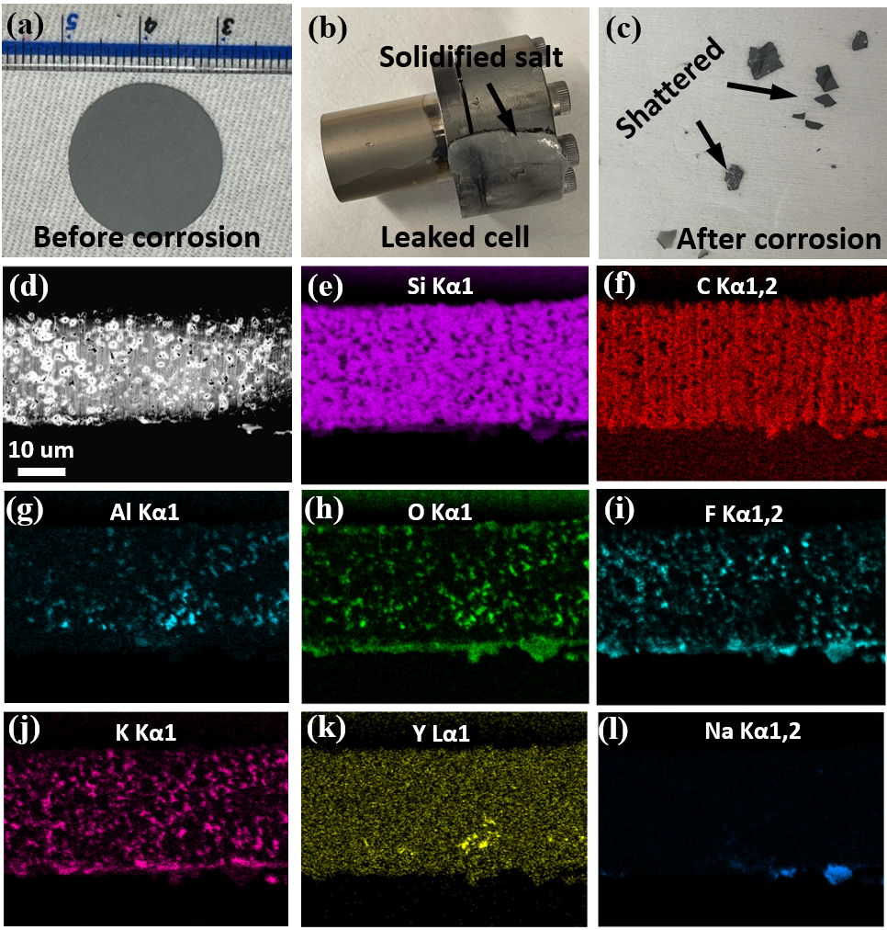

**Fig. 5.** Integrity of LPS SiC foil before and after exposure to molten FLiNaK at 650°C and cross-sectional morphology and chemistry. (a) Intact sample foil before corrosion. (b) Corrosion cell with leaked and solidified salt outside the cell. (c) Shattered SiC pieces after corrosion. (d) SEM image of cross-sectional morphology after corrosion, and (e-l) corresponding EDS mappings.

Fig. 5(d) shows the SEM-InLens image of the cross-section of the LPS SiC foil after exposure to molten FLiNaK at 650°C. The corresponding EDS mappings in Fig. 5(e-l) reveal that K and F predominantly invaded the interior of the sample foil, with their penetration percolating throughout the foil. This thorough penetration of K and F suggests that they interacted with metallic oxide additives and caused the foil to break. Na appears not to have penetrated the sample. Since it is not possible to detect Li in EDX analysis, this work will not focus on it. Therefore, the following discussions will focus on K and F. Fig. 6 (a) and (b) are SEM InLens and SE images, respectively, showing localized Al2O3 (marked by a white dashed ellipse) and a cavity (marked by a yellow dashed rectangle) partially filled with Al2O3, both affected by the salt. The associated EDX mappings in Fig. 6 (c-k) reveal that K predominantly combines with Al2O3, while F primarily fills the cavity.

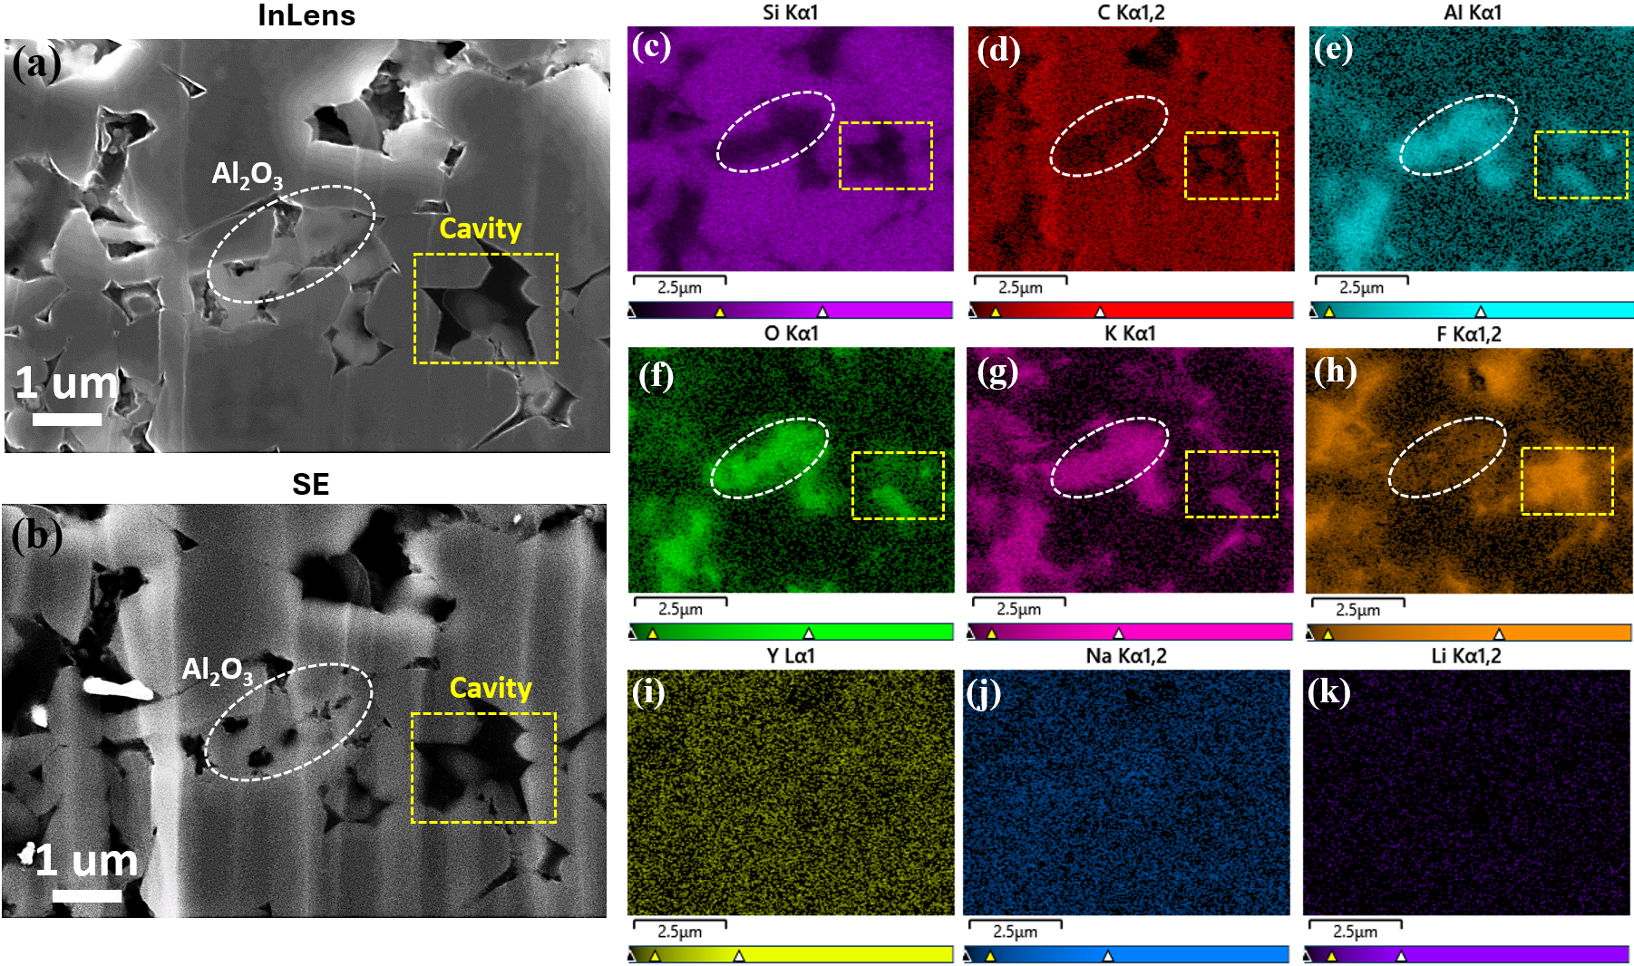

**Fig. 6.** (a) and (b) SEM InLens and SE mode images of localized Al2O3 and a cavity, both affected by molten FLiNaK at 650°C. (c-k) EDX mapping of (a) showing the elemental distribution.

Fig. 7 illustrates an additive with a mixture of Al2O3 and Y2O3. The SEM InLens image in Fig. 7(a) shows the mixed oxides circled by a white dashed line in an arbitrary shape. The SE mode image in Fig. 7(b) highlights the Y2O3, where its contrast appears brighter. This difference in SE and InLens images of Y2O3 is also demonstrated in section 3.1. As the EDS mappings in Fig. 7(c-k) show, K and F are mostly distributed around the mixed oxide, with less intensity of K and F observed in Fig. 7(i) and (h), respectively. This suggests that Y2O3 is more inert in reacting with K compared to F. It has also been shown that Y2O3-ZrO₂ coatings are more corrosion-resistant than aluminized NiCrAlY-bond coatings in LiCl–Li2O molten salt [28]. Therefore, it is likely that Al₂O₃ is less resistant to dissociation in molten FLiNaK compared to Y₂O₃. Given this, we will focus our discussion on the interaction between Al₂O₃ and molten FLiNaK, using SiC as a baseline reference for comparison in these reactions.

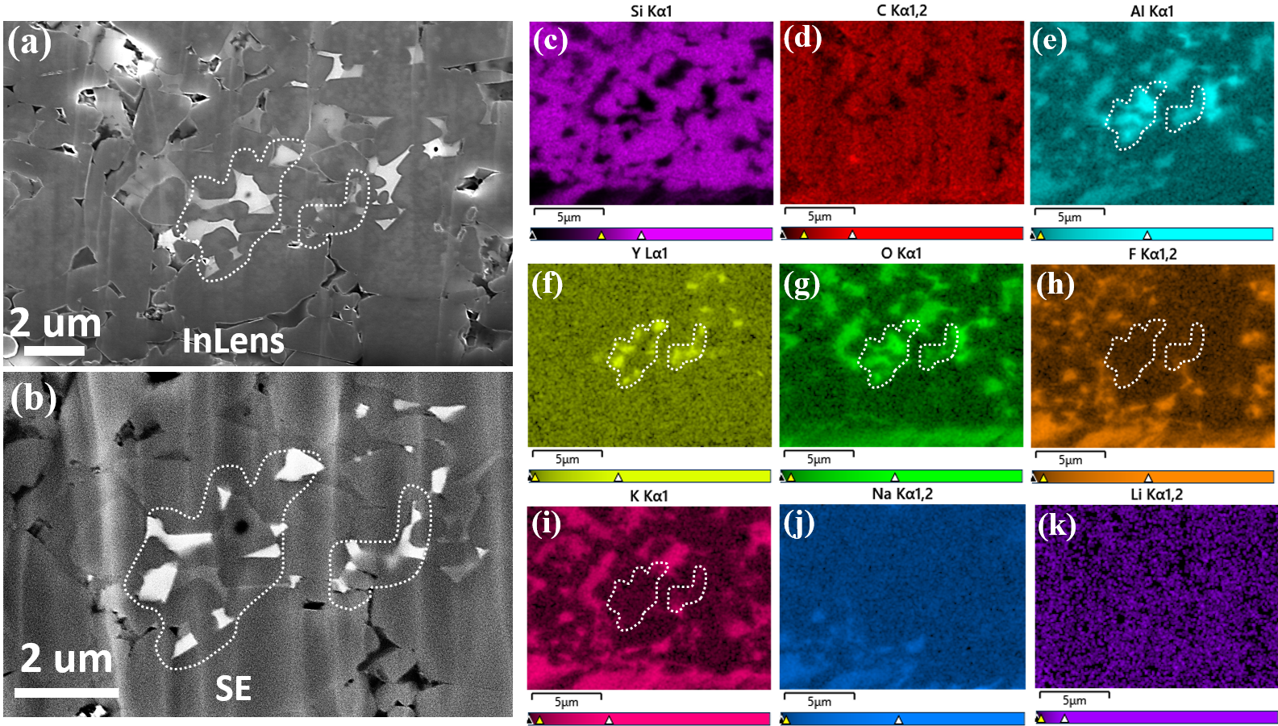

**Fig. 7.** Additive with a mixture of Y2O3 and Al2O3 surrounded by K and F after exposing LPS SiC foil to molten FLiNaK at 650°C. (a) and (b) are SEM InLens and SE images, respectively. (c-k) EDS mapping of (a) showing the elemental distribution.

Beyond the attack on oxide additives, molten FLiNaK can also attack the SiC matrix. Fig. 8(a) displays an SEM-InLens image of localized corrosion of SiC, marked by a red dashed line. The corroded SiC appears porous with many holes. The EDS line scan results across the two corroded SiC regions are presented in Fig. 8(b), showing the depletion of Si while enriching in C and K, with slight increase in the F intensity. This indicates that Si dissolves into KF, leaving C behind, consistent with observations in literature [8]. It can also be seen from Fig. 8(b) that the intensities of Al and O are nearly zero throughout the line, which suggests the observed morphology is due to SiC corrosion. For regions where Al2O3 has been corroded, typically some Al can still be detected suggesting that corrosion products of Al2O3 are not readily transported out of the sample. This is further evidence that the additives were not part of the localized corrosion of SiC shown in Fig. 8.

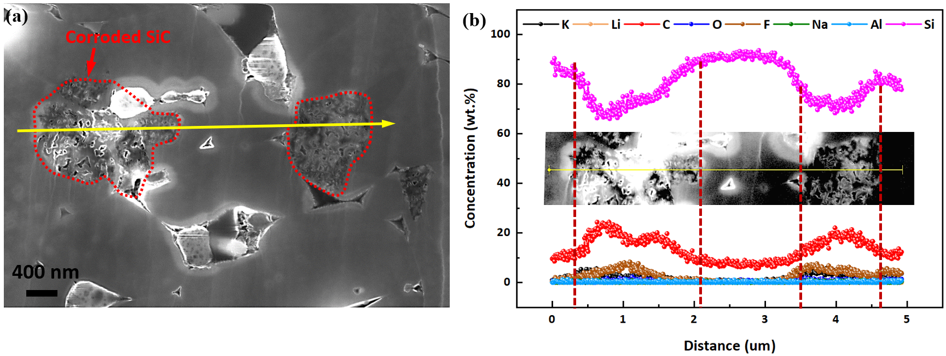**Fig. 8.** SiC corroded by FLiNaK at 650°C. (a) SEM InLens image showing the morphology of corroded SiC. (b) EDS results along the line in (a) showing the elemental profile.

Knowing that KF reacts with both Al₂O₃ and the SiC matrix, the surface (inteface) exposed to molten FLiNaK can provide insight into the dismantling process of SiC grains and the dissolution of Si in the SiC grain. As shown in Fig. 9(a) and (b), SEM InLens and SE images respectively, the red dashed line circles highlight the surface area where SiC grains underwent the dismantling process while being exposed to molten FLiNaK at 650°C. The large spatial gap between grains in the red circles, compared to the sealed grain boundary further from the surface, indicates the breakdown of the grain structure of SiC. The corresponding EDS mapping of the rectangle in Fig. 9(b) shows the elemental distribution in Fig. 9(c-k), verifying that K and F have enriched in the same region marked by the red dashed line circle. This suggests that K and F predominantly attacked the Al₂O₃ additives at grain boundaries, leading to the separation of SiC grains from the substrate. Simultaneously, the orange dashed line circle on the right-hand side of Fig. 9(a) and (b) shows a region where Si dissolves into the molten FLiNaK, leaving C enriched behind. The EDS mapping verifies that Si is barely detected in this region while the C intensity is stronger than in the surrounding areas. The agglomeration of K and F in the loosened region may cause further dissolution of SiC.

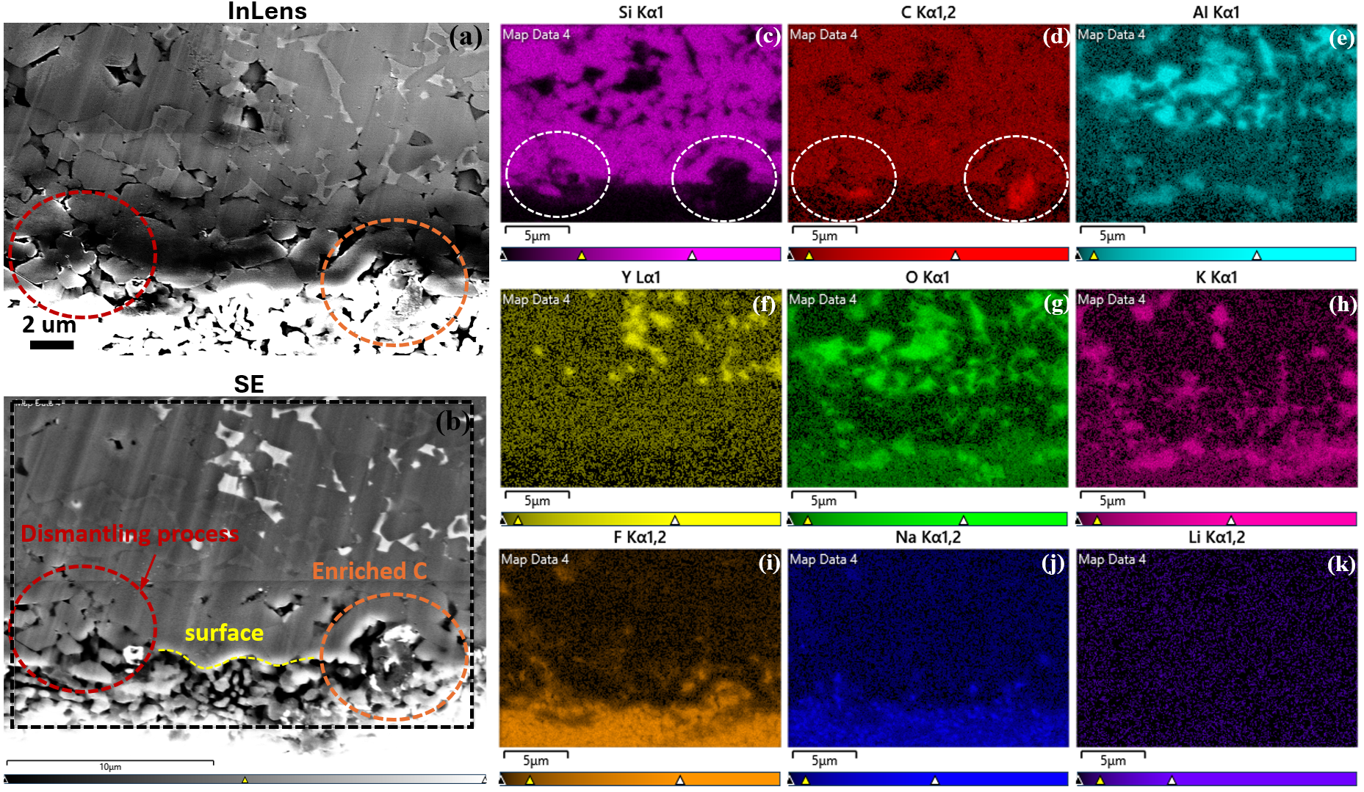

**Fig. 9.** Morphology and chemistry at the interface between LPS SiC and molten FLiNaK at 650°C. (a) and (b) are SEM InLens and SE images, respectively. (c-k) EDS mappings showing the elemental distribution from the rectangular area marked in (b).

**3.3 EPMA and XPS study**

EPMA results in Fig. 10 show that the distribution of oxide additives is not uniform across the sample, with stronger Al, Y, and O intensities in the upper left-side of the region in Fig. 10(e), (h) and (g), respectively. From the BSE image in Fig. 10(d), it can be observed that there are more pores in the bottom right-side region where fewer oxide additives are embedded in the matrix, with the white dashed line indicating the boundary. This proves the fact that these oxide additives enhance the binding of SiC during sintering. In the porous regions, more K and F can be detected, whereas less F is found in regions with oxide additives, consistent with the observation that F predominantly fills cavities. Additionally, Na and F tend to solidify on the surface as a layer a few micrometers thick, as seen in Fig. 10(i) and (a).

It is noted that C is not enriched in the oxide-embedded region, showing uniform intensity in Fig. 10(c), while K is scattered in the same region, as shown in Fig. 10(b). This suggests that the kinetics of the reaction between KF and Al2O3 additives are faster than that between KF and Si; otherwise, the dissolution of Si would lead to C enrichment in the region. It’s important to note the different behavior of Na and K as indicated in Fig. 10. Na appears in the region where more cavities are but rarely in the region where oxides are attacked. This suggests that NaF doesn't behave the same as KF in attacking oxides. Moreover, in the oxide region, LiF is likely involved, as KF remains solid at the experimental temperature, with a melting point above 800°C.

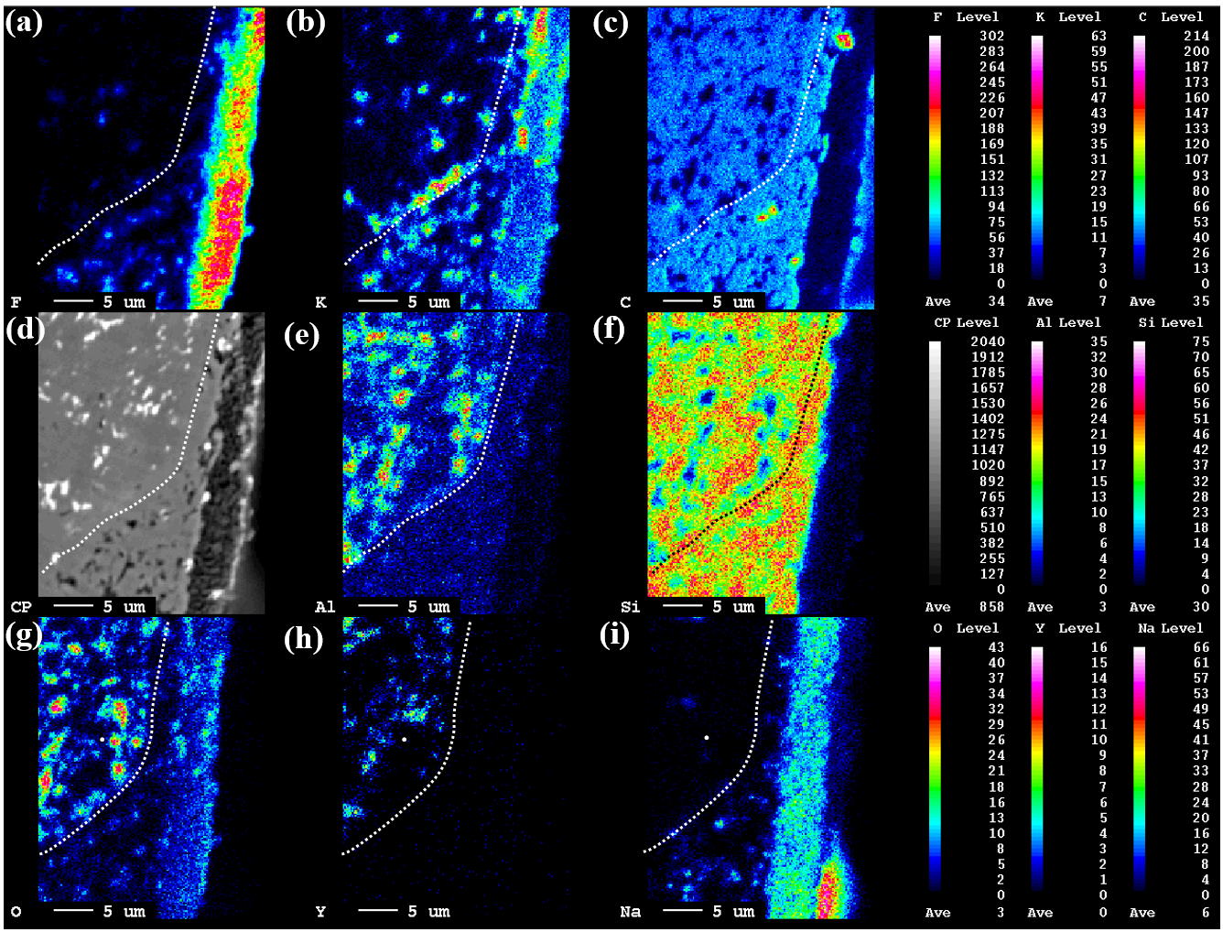

**Fig. 10.** EPMA mapping showing the elemental distribution across regions with and without oxide additives. (a)-(i), except for the SBE image in (d), are the EPMA elemental mappings.

To understand the corrosion products from SiC and oxide additives when interacting with molten FLiNaK at 650°C, high-resolution XPS was conducted on the surface after 1 minute of etching, as shown in Fig. 11. The Si 2p spectrum exhibits a peak near 105 eV, corresponding to Si⁴⁺, which can be attributed to SiF₄ [29]. Peaks at 103-104 eV are typically indicative of SiO2 [30]. In the Al 2p spectrum, the peaks appear complex; however, the peak near 76 eV can be assigned to Al-F, forming K2AlF4[31]. The Al₂O₃ peak usually appears near 74 eV, but with Y embedded, the binding energy should be slightly higher. Therefore, the Al 2p peak near 75 eV likely represents Al-Y-O oxides, similar to findings in other Co/Al₂O₃ studies [32]. The peak near 74 eV corresponds to AlO₂⁻, indicating the formation of KAlO₂. The formation of KAlO2 can be supported by K 2p spectrum where K+ 2p1/2 and 2p3/2 appear at 296eV and 293eV, respectively, as shown in Fig. 11(c)[33]. In the F 1s spectrum, the peak near 685.5 eV suggests metal fluorides such as KF, while the peak at 687.5 eV is likely associated with AlF3(K2AlF4), consistent with AlF3 XPS case studies [34]. The Y 3d peaks correspond solely to yttrium oxide, with no other peaks detected, unlike Al 2p. This suggests that Y₂O₃ is more stable than Al₂O₃, consistent with the results in Fig. 7.

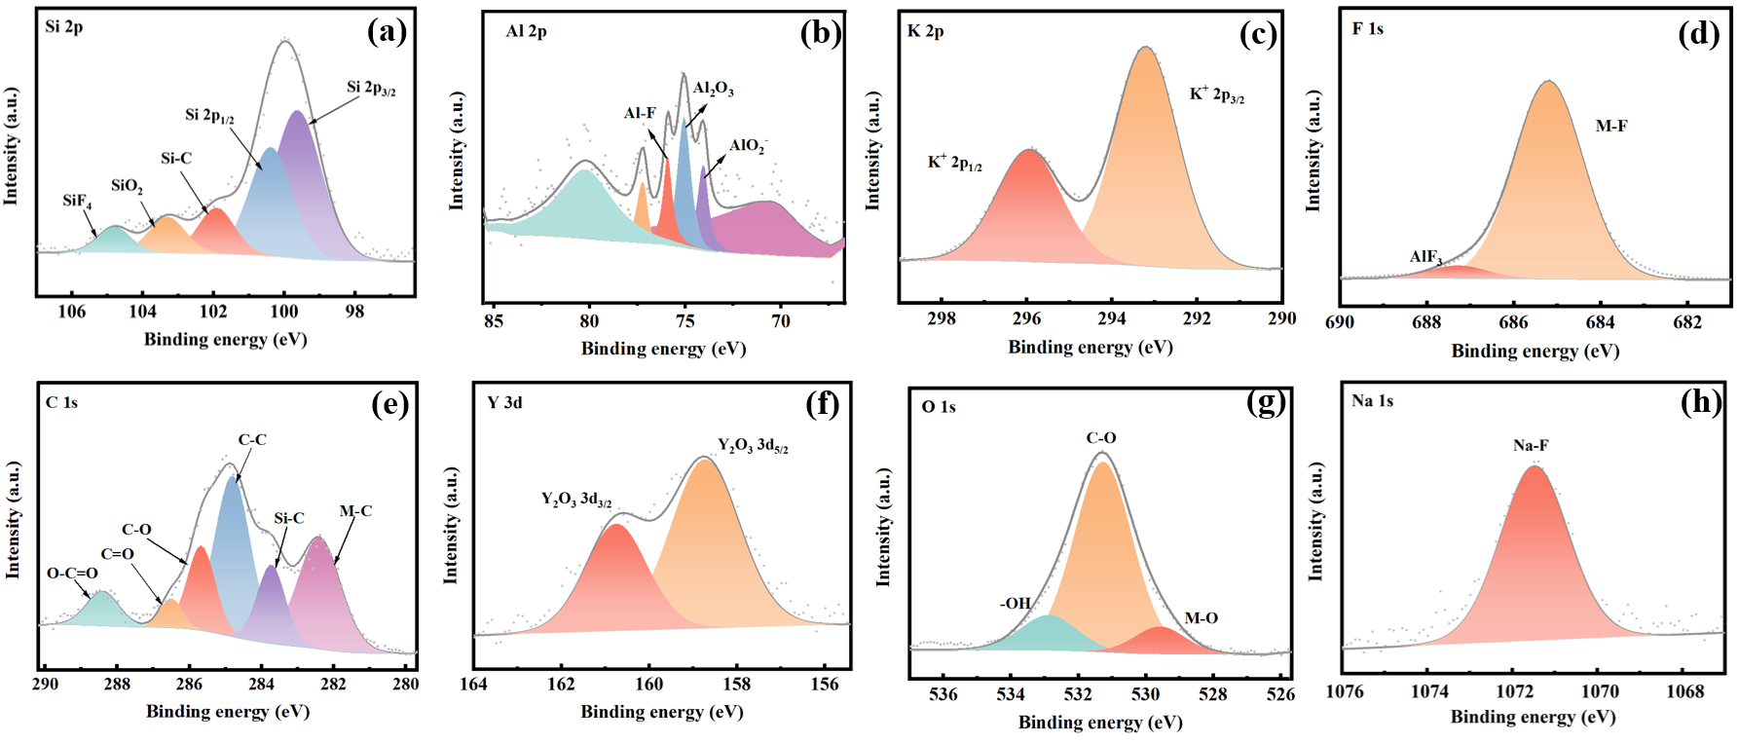

**Fig. 11.** High-resolution XPS results for different elements showing products after LSP SiC is exposed to molten FLiNaK at 650°C. (a) Si 2p. (b) Al 2p. (c) K 2p. (d) F 1s. (e) C 1s. (f) Y 3d. (g) O 1s. (h) Na 1s.

**3.4 Discussion**

**3.4.1 KF reaction with Al2O3 and SiC**

Based on the observations in Figs. 6 and 7, it is evident that Al₂O₃ undergoes corrosion when exposed to molten FLiNaK at 650°C, as K combines with Al₂O₃. The XPS Al 2p spectrum indicates the presence of AlO₂⁻, suggesting the following reaction through which solid Al₂O₃ likely transforms into liquid KAlO₂:

$2{Al}_{2}O_{3}+3KF= 2{AlF}_{3}+3{KAlO}_{2}$ (3)

In the liquid salt, AlF3 may exist as AlF4- via following equation, according to the thermodynamic data in Fig. 12,

$KF+AlF_{3} = {KAlF}_{4}$ (4)

Another alternative reaction between Al₂O₃ and KF could be as follows:

${Al}_{2}O_{3}+6KF= 2{AlF}_{3}+3K_{2}O$ (5)

However, KAlO₂ is thermodynamically more stable than K₂O, as supported in Fig. 12. Therefore, reaction (5) is unlikely to be the overall reaction, while reaction (3) is likely the overall reaction supported by the XPS measurements.

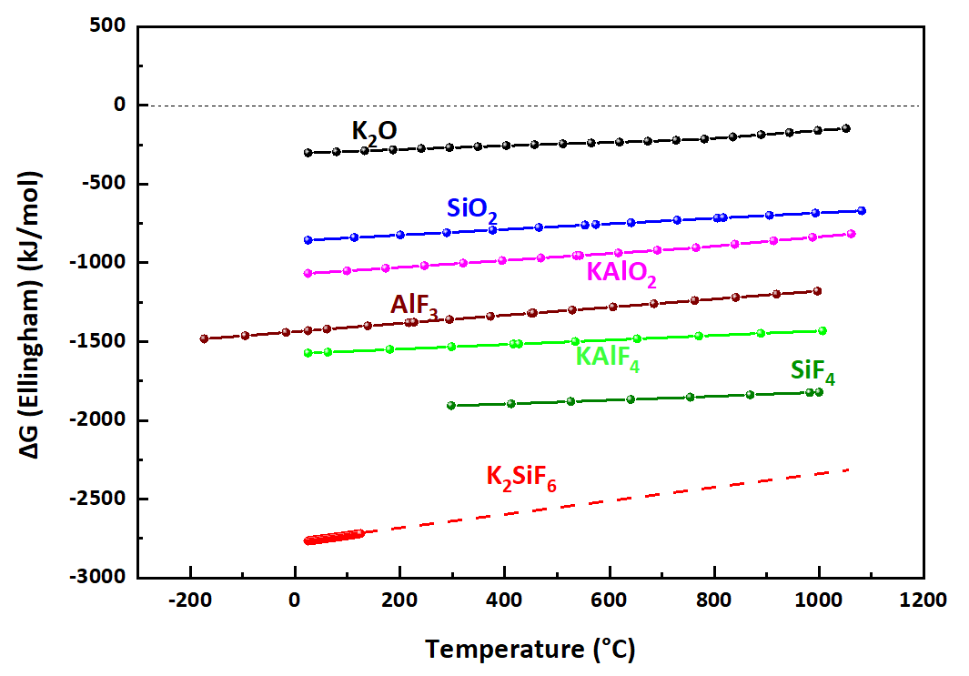

**Fig. 12.** Ellingham diagram representing the standard Gibbs free energy as a function of temperature. The data is extraction from HSC 9. The dash line is extrapolated.

At the same time, SiC could undergo dissolution, with Si leaching out from SiC when exposed to molten FLiNaK at 650°C. This is evidenced by the results shown in Figs. 8 and 9, where EDS analysis indicates the enrichment of C in areas where Si is depleted. The depletion of Si would create free volumes in the matrix, which may agglomerate and create tunnels for KF penetration into the SiC matrix, leading to further dissolution of SiC. Fig. 8 reflects the porous structure of SiC which is attacked by molten salt. It should be noted that SiC has a naturally formed SiO₂ passivation film. However, SiO₂ is unstable in molten salt and will dissolve in KF, forming SiF₄ through the reaction:

${SiO}_{2}+4KF= {SiF}_{4}+2K_{2}O$ (6)

SiF₄ could further react to form SiF₆²⁻ via the reaction depending on the fluoroacidity of the salt [35, 36]:

$2KF+{SiF}_{4}= K_{2}{SiF}_{6}$ (7)

The tendency for SiO₂ to transform into SiF₄ and then to K₂SiF₆ can be further supported by the thermodynamic data in Fig. 12, where K₂SiF₆ has the lowest energy.

Here arises the central question: which material, Al₂O₃ or SiC, is more favorable for reacting with molten FLiNaK? To investigate this, Density Functional Theory (DFT) calculations were conducted to compare the adsorption energy of KF on Al₂O₃ and SiC, respectively. As illustrated in Fig. 13(a-d), the simulations examined different chemical facets of SiC and Al₂O₃: (a) KF molecule on Si-terminated SiC, (b) KF molecule on C-terminated SiC, (c) KF molecule on Al-terminated Al₂O₃, and (d) KF molecule on O-terminated Al₂O₃. All surfaces were modeled in the <001> direction.

After structural optimization, the F atom forms a bond with Si in Fig. 13(a) with a bond length of approximately 1.64 Å, while no bond forms with K. Similarly, in Fig. 13(b), F forms a bond with C at the C-terminated SiC. For Al₂O₃, in Fig. 13(c), KF forms bonds with both O and Al on the Al-terminated surface, with K forming three bonds with O with a bond length of 2.66 Å and F bonding with Al with a bond length of 1.74 Å. On the O-terminated Al₂O₃ surface shown in Fig. 13(d), only K forms a bond with O with a bond length of 2.64 Å.

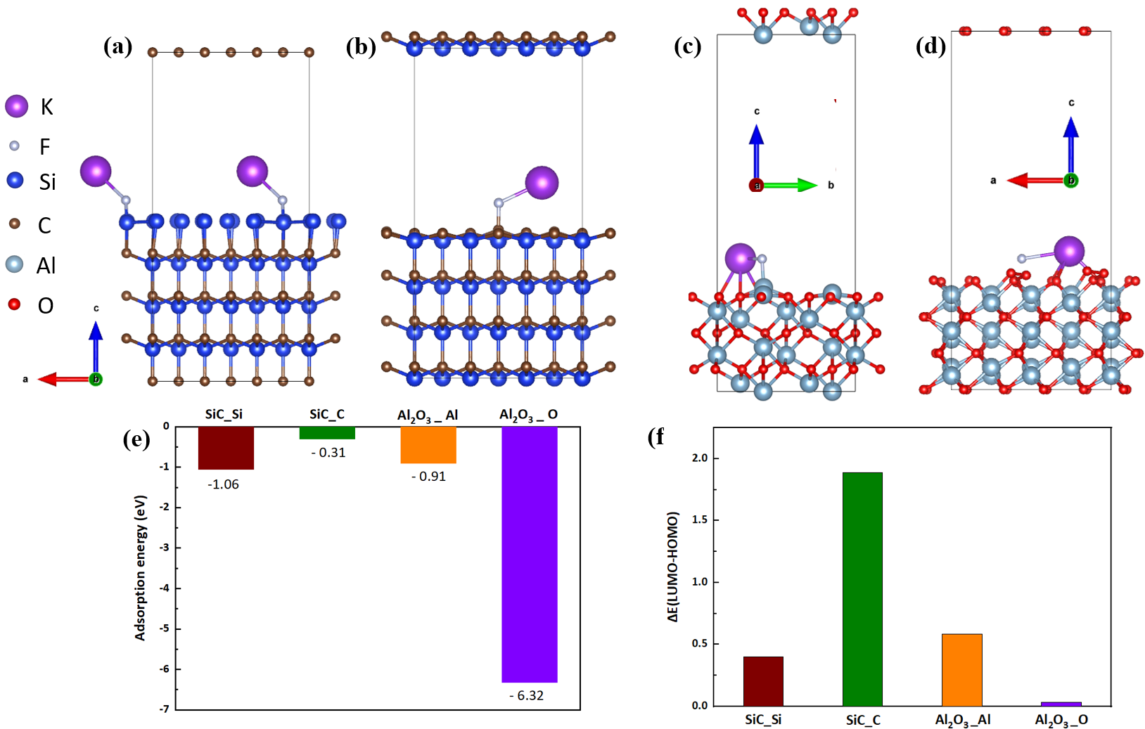

**Fig. 13.** DFT calculation of adsorption energy and energy gap of HOMO-LUMO. (a) KF molecule on Si-terminated SiC, (b) KF molecule on C-terminated SiC, (c) KF molecule on Al-terminated Al₂O₃, and (d) KF molecule on O-terminated Al₂O₃. (e) Summarized adsorption energy of KF on different substrates. (f) Summarized energy gap of HOMO-LUMO on different substrates.

Fig. 13(e) summarizes the adsorption energy of KF on different chemical terminations of SiC and Al₂O₃. The adsorption energy of KF on O-terminated Al₂O₃ is the highest at -6.32 eV, followed by -1.06 eV on Si-terminated SiC. The adsorption energy of KF on C-terminated SiC is the lowest at -0.31 eV. This significant difference indicates that KF is more likely to be adsorbed by Al₂O₃ than by SiC at the early stages of the reaction.

This tendency is further supported by the energy gap between the highest occupied molecular orbital (HOMO) and the lowest unoccupied molecular orbital (LUMO). The O-terminated Al₂O₃ exhibits the smallest energy gap of 0.0035 eV, compared to 0.04 eV for Si-terminated SiC. The smaller HOMO-LUMO gap in O-terminated Al₂O₃ suggests that electron transfer is more facile, promoting more efficient adsorption and reaction with KF.

Fig. 14 illustrates the Electron Localization Function (ELF) of the Si-F bond formed on Si-terminated SiC and the K-O bond formed on O-terminated Al₂O₃. The ELF measures the probability of finding an electron pair in the vicinity of a given point in space [37]. The isosurfaces of electron distribution in Fig. 14(b) and (d) were generated by slicing the surface across the atoms under investigation, as indicated in Fig. 14(a) and (b). As seen in Fig. 14(b), the Si-F bond tends to be covalent, with electron density localized in the bond region between the Si and F atoms. In the figure, an intensity of 1 represents the highest electron density, while an intensity of 0 indicates the lowest electron density. Due to F's high electronegativity, this bond tends towards a polar covalent character, with more electron localization towards the F atom. In contrast, the K-O bond appears ionic, with no significant electron localization in the bond region between K and O.

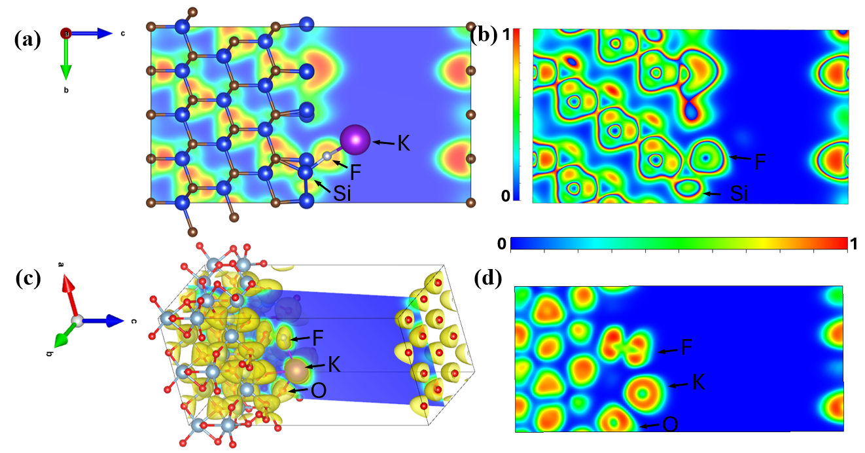

**Fig. 14.** DFT calculation of the Electron Localization Function (ELF) for the Si-F bond formed on Si-terminated SiC and the K-O bond formed on O-terminated Al₂O₃. (a) and (c) show the 3D structures of SiC and Al₂O₃ with bonded KF, respectively. (b) and (d) display the isosurfaces corresponding to (a) and (c), respectively.

These calculations suggest a higher favorability of KF reacting with Al₂O₃ compared to SiC, which aligns with the experimental observations. As shown in Fig. 5, K and F penetrate throughout the sample foil, with K combining with Al and O. This indicates that the reaction between KF and Al₂O₃ occurs across the entire sample thickness. In contrast, the reaction between SiC and KF is not as apparent throughout the sample foil. Additionally, SiC grains under corrosion are sparse at the interface between molten FLiNaK and SiC in Fig. 9, where only two grains show a significant depletion of Si and enrichment of C.

**3.4.2 Dismantling process of LPS SiC in molten salt**

Based on the possible reactions during the corrosion of Al₂O₃ and SiC when exposed to molten FLiNaK at 650°C, as discussed in Section 3.4.1, the dismantling process of SiC grains is illustrated in the schematic shown in Fig. 15. Firstly, as illustrated in Fig. 15(a), when LPS SiC is exposed to molten FLiNaK at 650°C, the molten salt preferentially penetrates through the grain boundaries (GBs) where oxide additives are embedded as indicated in orange in Fig. 15(a). This is evidenced in Fig. 4 where the brighter contrast indicates the presence of oxides at the GBs. Additionally, the sample foil has many pores as part of its original microstructure, as shown in Fig. 3. These cavities are highlighted in white at the GBs in Fig. 15(a). The penetration of molten salt leads to reactions between KF and Al₂O₃, forming dissolved KAlO₂, as indicated by the light pinkish colors in Fig. 15(b), which represents the transition from Al₂O₃ to KAlO₂. The cavities are also filled with molten salt, predominantly F, as evidenced in Fig. 6.

As Al2O3 surrounding a SiC grain dissolve into the molten salt, the SiC grain tends to spall off from the matrix. This happens because the oxides, which play a crucial role in binding the SiC grains together to form a dense matrix, get loosened, as demonstrated in Fig. 15(c). This spalling process was confirmed in the experimental observations shown in Fig. 9, where SiC grains are detached from the matrix at the interface of molten salt and LPS SiC foil. On the other hand, as evidenced by Figs. 8, 9, and 13, the SiC grain itself undergoes corrosion when exposed to the molten salt, resulting in the dissolution of Si from the SiC substrate and leaving C behind. This is illustrated in Fig. 15(c), where the edge of the spalled grain shows a depletion of Si, indicated by the light blue color.

The intergranular penetration causes localized corrosion, which penetrates much deeper and eventually extends through the entire sample thickness, leading to the percolation of corrosion throughout the sample as illustrated in Fig. 15(d). This penetration introduces cracks along the penetration path, ultimately causing the sample to break into pieces. This process is evidenced experimentally in Fig. 5, where the sample foil was broken after exposure to molten FLiNaK at 650°C. The EDS mapping provides evidence of K and F distributed throughout the sample thickness, supporting the percolation of the spaces for salt to penetrate through. As exposure to molten salt continues for a longer time, the SiC grains become increasingly enriched with C as more silicon dissolves into the molten salt, as illustrated in Fig. 15(d).

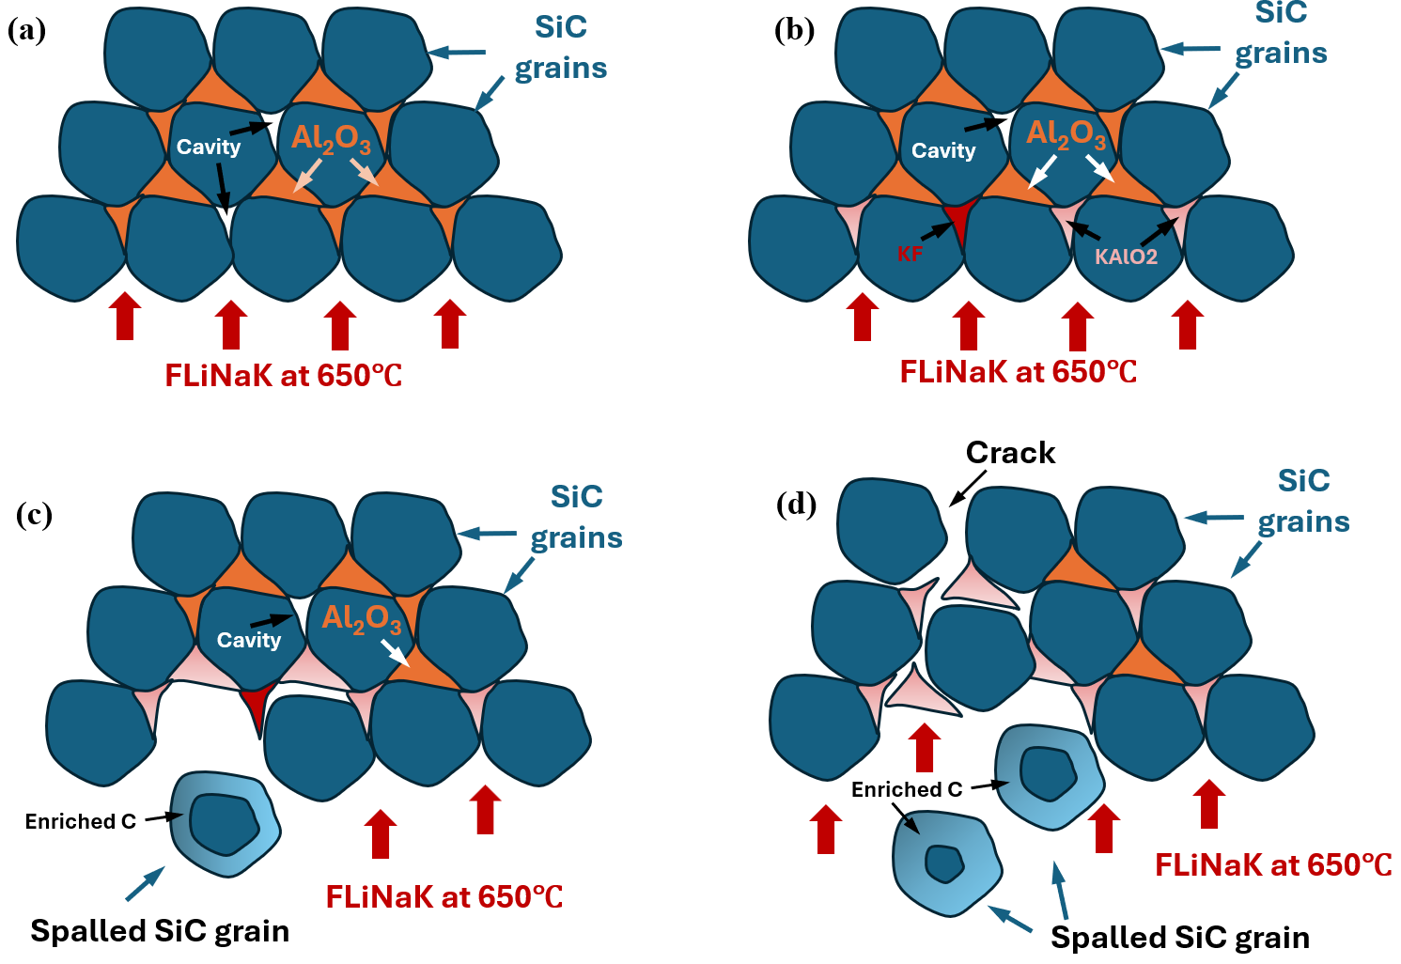

**Fig. 15.** Schematics illustrating the dismantling process of SiC grains exposed to molten FLiNaK at 650°C. (a) Fresh LPS SiC exposed to molten FLiNaK at 650°C. (b) Molten salt invades the sample via grain boundaries, causing the dissolution of Al₂O₃. (c) SiC grains spall off from the matrix. (d) More SiC grains detach from the matrix, leading to cracks percolating through the sample thickness and causing the sample to shatter.

This study pointed out that LPS SiC with oxide additives is susceptible to molten salt corrosion, with the oxide additives driving the breakdown of the sample through their dissolution. The dissolution of these additives creates pathways for the molten salt to invade the material, leading to the disintegration of the SiC grains. Different oxides have different susceptibility to fluoride salts as indicated by the different behavior of Al2O3 and Y2O3 in this work. This suggests that when considering sintering additives for SiC in applications where SiC directly touches molten fluorides, one should choose oxides that are more resistant to fluoride attack and Al2O3 is not a suitable oxide to use in molten FLiNaK. In future studies, it would be valuable to investigate how the concentration of these additives influences the corrosion process. Understanding the relationship between additive concentration, density of sintered SiC, and corrosion behavior could provide insights into how to control the extent of corrosion. Specifically, optimizing the concentration of additives might limit the percolation of cracks and enhance the overall durability of the material. In addition, a denser, less porous structure could also improve corrosion resistance, as the channels for penetration would be reduced in a denser matrix. Moreover, different fluorides seem to behave differently at attacking oxides but not SiC. Testing different combination of fluorides would be useful if KF is the one mostly responsible for attacking oxide additives. This research could lead to the development of more robust SiC-based materials for applications involving exposure to harsh environments, such as those involving molten salts.

**3.5 Conclusion**

In this study, we investigated the chemical compatibility of LPS SiC with Al₂O₃/Y₂O₃ additives when exposed to molten FLiNaK at 650°C through both experimental methods and DFT calculations. The key findings are as follows:

1. LPS SiC undergoes significant corrosion, with Al₂O₃ at grain boundaries predominantly dissolving into the molten salt and forming KAlO₂ and K2AlF4. This process leads to the formation of cracks that percolate through the sample thickness.
2. The corrosion of SiC involves interaction with KF, resulting in the depletion of Si and enrichment of C. SiO₂ dissolves into KF, forming SiF₄/ K₂SiF₆, depending on the fluoroacidity of the salt.
3. DFT calculations revealed that the adsorption energy of KF on Al₂O₃ is an order of magnitude higher than that on SiC. This indicates a higher tendency for KF to preferentially associate with Al₂O₃ compared to SiC, supporting the experimental observations.

***References***

[1] Y. Katoh, L.L. Snead, C.H. Henager, T. Nozawa, T. Hinoki, A. Ivekovic, S. Novak, S.M.G. de Vicente, Current status and recent research achievements in SiC/SiC composites, J Nucl Mater 455(1-3) (2014) 387-397.

[2] Y. Katoh, K. Ozawa, C. Shih, T. Nozawa, R.J. Shinavski, A. Hasegawa, L.L. Snead, Continuous SiC fiber, CVI SiC matrix composites for nuclear applications: Properties and irradiation effects, J Nucl Mater 448(1-3) (2014) 448-476.

[3] J.J. Li, L. Yan, H.F. Huang, Q. Huang, C.L. Ren, G.H. Lei, J. Lin, C.L. Fu, J.J. Bai, Corrosion behavior of ion-irradiated SiC in FLiNaK molten salt, Corros Sci 163 (2020).

[4] Y.W. Lei, Y.G. Zhang, X.Y. Li, Y.C. Xu, X.B. Wu, M. Sun, B.S. Li, C.S. Liu, Z.G. Wang, Simulation and experimental studies of the dissolution corrosion of 4H-SiC in liquid Pb/Bi, Appl Surf Sci 585 (2022).

[5] C.W. Forsberg, P.F. Peterson, H.H. Zhao, High-temperature liquid-fluoride-salt closed-Brayton-cycle solar power towers, J Sol Energ-T Asme 129(2) (2007) 141-146.

[6] J.J. Lee, S.S. Raiman, Y. Katoh, T. Koyanagi, C.I. Contescu, X.X. Hu, Y. Yang, Chemical compatibility of silicon carbide in molten fluoride salts for the fluoride salt-cooled high temperature reactor, J Nucl Mater 524 (2019) 119-134.

[7] Y.F. Gu, J.X. Liu, Y. Wang, J.X. Xue, X.G. Wang, H.B. Zhang, F.F. Xu, G.J. Zhang, Corrosion behavior of TiC-SiC composite ceramics in molten FLiNaK salt, J Eur Ceram Soc 37(7) (2017) 2575-2582.

[8] J.Q. Xi, H. Jiang, C. Liu, D. Morgan, I. Szlufarska, Corrosion of Si, C, and SiC in molten salt, Corros Sci 146 (2019) 1-9.

[9] W.D. Xue, X.M. Yang, J. Qiu, H.J. Liu, B. Zhao, H.H. Xia, X.T. Zhou, P. Huai, H.T. Liu, J.Q. Wang, Effects of Cr on the corrosion of SiC in LiF-NaF-KF molten salt, Corros Sci 114 (2017) 96-101.

[10] X.M. Yang, M. Liu, Y.T. Gao, D.S. Zhang, S.L. Feng, H.J. Liu, G.J. Yu, G.Z. Wu, M.H. Wang, X.T. Zhou, H.H. Xia, P. Huai, T.K. Sham, J.Q. Wang, J.H. Guo, Effect of oxygen on the corrosion of SiC in LiF-NaF-KF molten salt, Corros Sci 103 (2016) 165-172.

[11] L.J. Espinoza-Pérez, S. Esquivel-Medina, E. López-Honorato, Influence of SiC microstructure on its corrosion behavior in molten FLiNaK salt, Ceram Int 47(11) (2021) 15527-15532.

[12] B.R. Lawn, N.P. Padture, H.D. Cai, F. Guiberteau, Making Ceramics Ductile, Science 263(5150) (1994) 1114-1116.

[13] A.L. Ortiz, A. Muñoz-Bernabé, O. Borrero-López, A. Domínguez-Rodríguez, F. Guiberteau, N.P. Padture, Effect of sintering atmosphere on the mechanical properties of liquid-phase-sintered SiC, J Eur Ceram Soc 24(10-11) (2004) 3245-3249.

[14] X.D. Wang, X.M. Yang, M.M. Hu, H.J. Liu, S.L. Liu, X.T. Zhou, Corrosion behavior of pressureless-sintered SiC in molten NaCl-KCl-MgCl salt at 700°C, Sol Energ Mat Sol C 242 (2022).

[15] M.M. Hu, X.M. Yang, X.D. Wang, H.J. Liu, X.T. Zhou, Corrosion behavior of pressureless sintered SiC in molten LiF-NaF-KF salt: of metallic impurities in the salt, Corros Sci 201 (2022).

[16] N. AlMousa, W.Y. Zhou, K.B. Woller, M.P. Short, Effects of simultaneous proton irradiation on the corrosion of commercial alloys in molten fluoride salt, Corros Sci 217 (2023).

[17] M.F. Montemor, A.M. Simoes, M.J. Carmezim, Characterization of rare-earth conversion films formed on the AZ31 magnesium alloy and its relation with corrosion protection, Appl Surf Sci 253(16) (2007) 6922-6931.

[18] G. Kresse, J. Furthmuller, Efficient iterative schemes for ab initio total-energy calculations using a plane-wave basis set, Phys Rev B 54(16) (1996) 11169-11186.

[19] D.D. Liu, Y.L. Shi, L. Tao, D.F. Yan, R. Chen, S.Y. Wang, First-principles study of methanol adsorption on heteroatom-doped phosphorene, Chinese Chem Lett 30(1) (2019) 207-210.

[20] Q.N. Zhou, L.Y. Zhu, C.Y. Zheng, J. Wang, Nanoporous Functionalized WS

/MWCNTs Nanocomposite for Trimethylamine Detection Based on Quartz Crystal Microbalance Gas Sensor, Acs Appl Mater Inter 13(34) (2021) 41339-41350.

[21] G. Kresse, D. Joubert, From ultrasoft pseudopotentials to the projector augmented-wave method, Phys Rev B 59(3) (1999) 1758-1775.

[22] J.P. Perdew, K. Burke, M. Ernzerhof, Generalized gradient approximation made simple, Phys Rev Lett 77(18) (1996) 3865-3868.

[23] H.J. Monkhorst, J.D. Pack, Special Points for Brillouin-Zone Integrations, Phys Rev B 13(12) (1976) 5188-5192.

[24] A. Esme, S.G. Sagdinc, Spectroscopic (FT-IR, FT-Raman, UV-Vis) analysis, conformational, HOMO-LUMO, NBO and NLO calculations on monomeric and dimeric structures of 4-pyridazinecarboxylic acid by HF and DFT methods, J Mol Struct 1147 (2017) 322-334.

[25] V.D. Frechette, J.R. Varner, Fractography of glasses and ceramics, American Ceramic Society Inc., Westerville, OK, 1988.

[26] P.L. Swanson, C.J. Fairbanks, B.R. Lawn, Y.W. MAI, B.J. Hockey, Crack‐interface grain bridging as a fracture resistance I, mechanism in ceramics: I, experimental study on alumina, Journal of the American Ceramic Society 70(4) (1987) 279-289.

[27] V. Haase, G. Kirschstein, H. List, S. Ruprecht, R. Sangster, F. Schröder, W. Töpper, H. Vanecek, W. Heit, J. Schlichting, H. Katscher, The Si-C Phase Diagram, in: H. Katscher, R. Sangster, F. Schröder (Eds.), Si Silicon: System Si-C. SiC: Natural Occurrence. Preparation and Manufacturing Chemistry. Special Forms. Manufacture. Electrochemical Properties. Chemical Reactions. Applications. Ternary and Higher Systems with Si and C, Springer Berlin Heidelberg, Berlin, Heidelberg, 1985, pp. 1-5.

[28] S.H. Cho, B.H. Park, J.M. Hur, H.S. Lee, K.C. Song, J.H. Lee, Corrosion behaviour of YO-ZrO coatings on IN713LC in a LiCl-LiO molten salt, Corros Sci 52(7) (2010) 2353-2364.

[29] C.-R. Wen, S. Frigo, R. Rosenberg, Reactions of SiF4 adsorbed on Si (111)(7× 7) at 30 K, Surface science 249(1-3) (1991) 117-128.

[30] D.S. Jensen, S.S. Kanyal, N. Madaan, M.A. Vail, A.E. Dadson, M.H. Engelhard, M.R. Linford, Silicon (100)/SiO2 by XPS, Surface Science Spectra 20(1) (2013) 36-42.

[31] A. Makarowicz, C.L. Bailey, N. Weiher, E. Kemnitz, S.L.M. Schroeder, S. Mukhopadhyay, A. Wander, B.G. Searle, N.M. Harrison, Electronic structure of Lewis acid sites on high surface area aluminium fluorides: a combined XPS and

investigation, Phys Chem Chem Phys 11(27) (2009) 5664-5673.

[32] J. Cañón, A.V. Teplyakov, XPS characterization of cobalt impregnated SiO2 and γ‐Al2O3, Surface and Interface Analysis 53(5) (2021) 475-481.

[33] Q. Wei, J. Hu, H. Zhang, G. Wang, X. Yang, Efficient Synthesis of Dimethyl Carbonate via Transesterification from Ethylene Carbonate with Methanol Using KAlO2/γ‐Al2O3 Heterogeneous Catalyst, ChemistrySelect 5(26) (2020) 7826-7834.

[34] J.C. Moreno-López, G. Ruano, J. Ferrón, P. Ayala, M.C.G. Passeggi, Thermally Annealed Sub-Monolayers of AlF on Cu(100): An STM and XPS Study, Phys Status Solidi B 255(12) (2018).

[35] M. Kergoat, L. Massot, M. Gibilaro, P. Chamelot, Investigation on fluoroacidity of molten fluorides solutions in relation with mass transport, Electrochim Acta 120 (2014) 258-263.

[36] A.L. Bieber, L. Massot, M. Gibilaro, L. Cassayre, P. Chamelot, P. Taxil, Fluoroacidity evaluation in molten salts, Electrochim Acta 56(14) (2011) 5022-5027.

[37] A. Savin, R. Nesper, S. Wengert, T.F. Fassler, ELF: The electron localization function, Angew Chem Int Edit 36(17) (1997) 1809-1832.